MODULE 6 ASSIGNMENT:
Question 1
Capture and analyze ARP packets using Wireshark. Inspect the ARP request and reply frames when your device attempts to find the router’s MAC address.
Discuss the importance of ARP in packet forwarding

Sol:
Run the ipconfig command to find out the active connections and get the IPv4 of the Wi-Fi
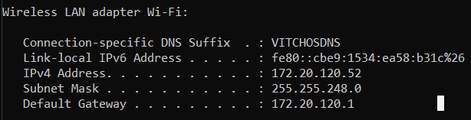
now use the ping command in the command prompt to ping the default gateway of your router and filter the packet filter as arp in wireshark and before the ping command use arp -d which clears the memory.

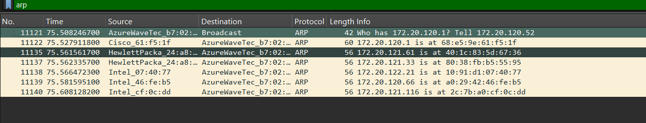

Question 2
Manually configure static routes on a router to direct packets to different subnets.
Use the ip route command and verify connectivity using ping and traceroute.
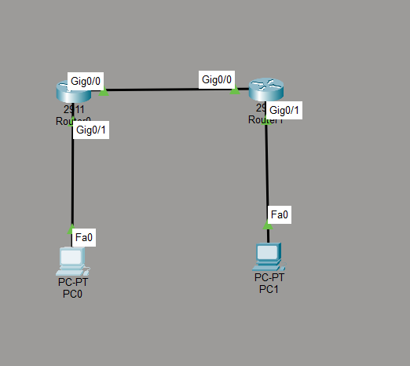
NETWORK
Router 0 configuration
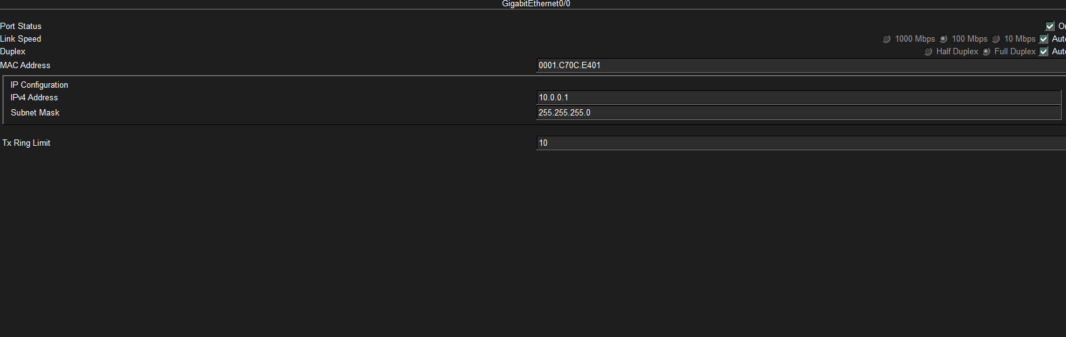

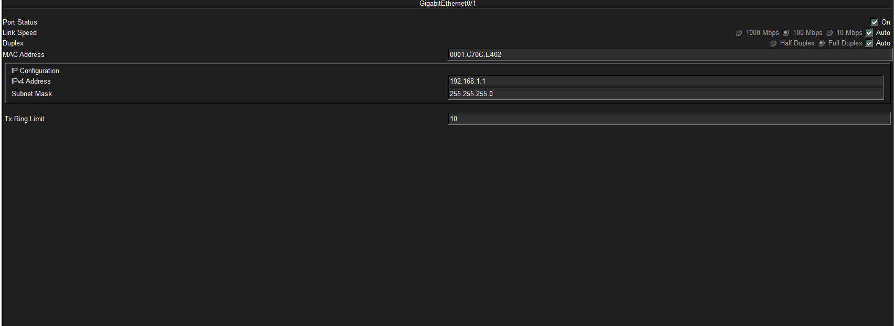
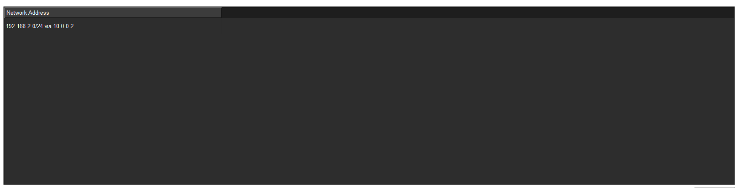

Router 1 configuration

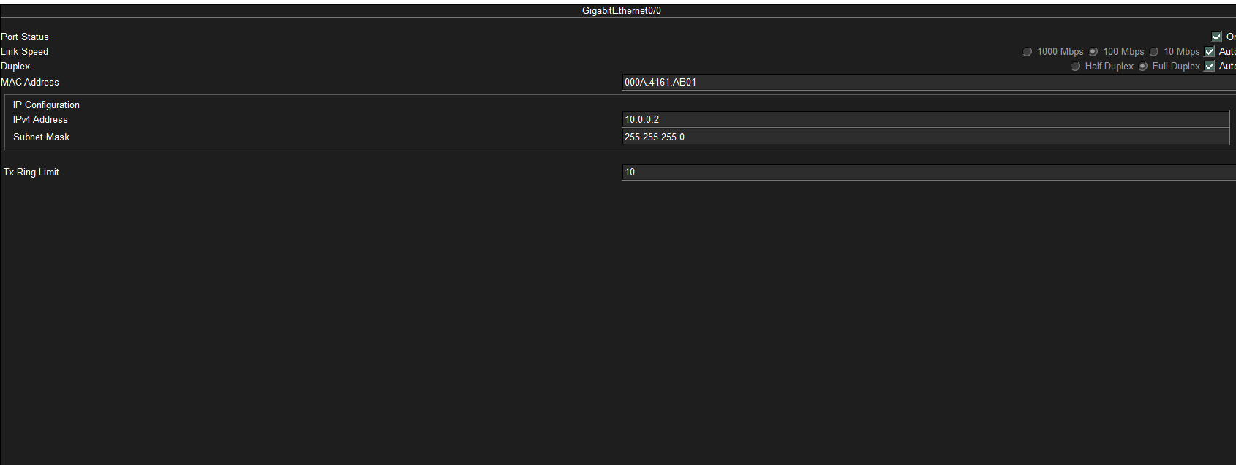

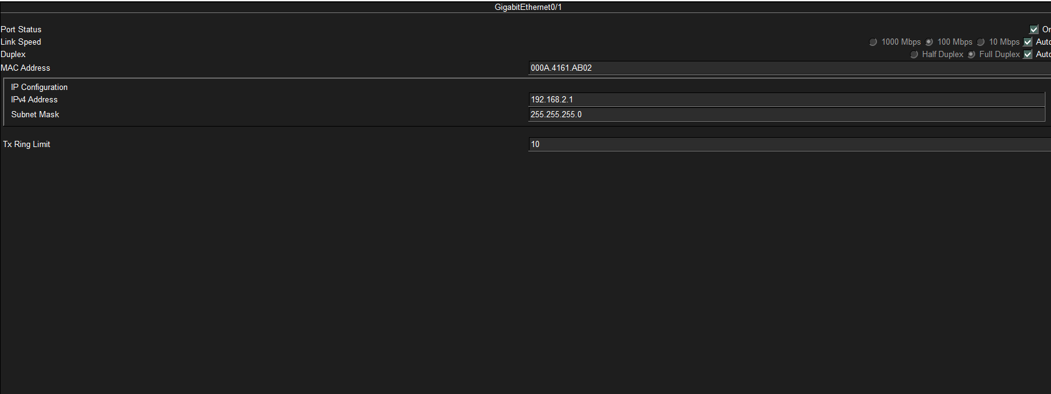

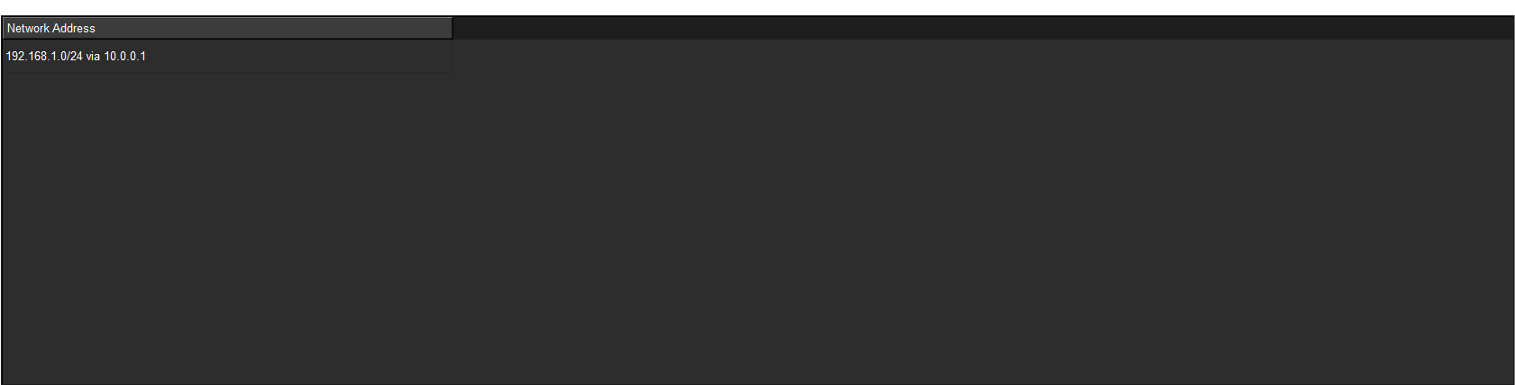

Entire IP configuration
Device | Interface | IP Address | Subnet Mask | Default Gateway
PC0 | FastEthernet0 | 192.168.1.10 | 255.255.255.0 | 192.168.1.1
PC1 | FastEthernet0 | 192.168.2.10 | 255.255.255.0 | 192.168.2.1
Router 0 | Gig0/1 (to PC0) | 192.168.1.1 | 255.255.255.0 | N/A
Router 0 | Gig0/0 (to R1) | 10.0.0.1 | 255.0.0.0 | N/A
Router 1 | Gig0/1 (to PC1) | 192.168.2.1 | 255.255.255.0 | N/A
Router 1 | Gig0/0 (to R0) | 10.0.0.2 | 255.0.0.0 | N/A
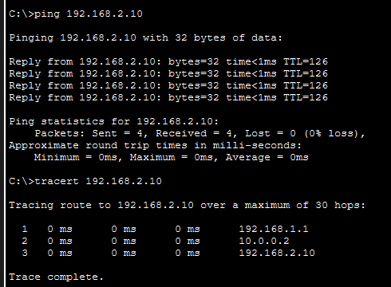

The successful execution of ping and tracert confirms that the manual static routing configuration is operational. By explicitly defining the network path using the ip route command, the routers are able to bridge traffic between two different Class C subnets. The traceroute results specifically validate the multi-hop path through the intermediate point-to-point link, demonstrating a correctly implemented routing logic.

Question 3
Given a network address of 10.0.0.0/24, divide it into 4 equal subnets.
- Calculate the new subnet mask
- Determine the valid host range for each subnet
- Assign IP addresses to devices in Packet Tracer
- Verify connectivity

Sol:
Device IP Address Subnet
PC0 192.168.1.2 Subnet 1
PC1 192.168.1.66 Subnet 2
PC2 192.168.1.130 Subnet 3
PC3 192.168.1.194 Subnet 4



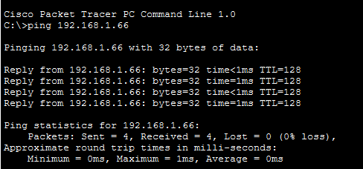

PC0-PC1

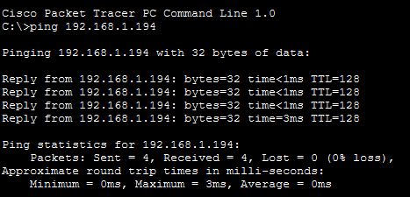

PC2-PC3

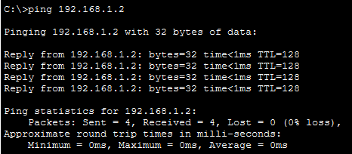

PC3-PC0
Multiple ping connections across the network have been checked and they are connected fine.

Question 4
You are given three IP addresses: 192.168.10.5, 172.20.15.1, and 8.8.8.8.
- Identify the class of each IP address.
- Determine if it is private or public.
- Explain how NAT would handle a private IP when accessing the internet.
Sol:
IP Address | Class | Category | Range / Reason
192.168.10.5 | Class C | Private | Within RFC 1918 range (192.168.0.0 - 192.168.255.255)
172.20.15.1 | Class B | Private | Within RFC 1918 range (172.16.0.0 - 172.31.255.255)
8.8.8.8 | Class A | Public | Globally routable address (Google Public DNS)

Translation (NAT) is required at the network gateway (router) to facilitate communication:
- Translation: When a private device sends a packet to the internet, the router replaces the Private Source IP with its own Public IP.
- Mapping: The router creates an entry in its NAT Table, mapping the internal device's request to a specific port.
- Reception: When the external server responds, the router uses the NAT Table to "translate" the destination back to the original Private IP and delivers the data to the correct internal host.
- Security/Conservation: This process masks the internal network structure and allows multiple devices to share a single public IPv4 address.

Question 5
In Cisco Packet Tracer, create a small network with multiple devices (e.g., 2 PCs and a router). Use private IP addresses (e.g., 192.168.1.x) on the PCs and configure the router to perform NAT to allow the PCs to access the internet.

Sol:
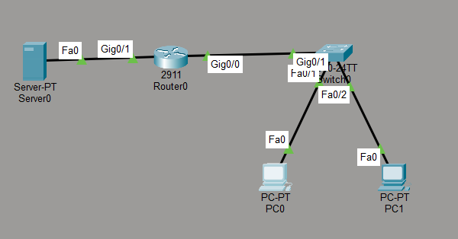
Topology

Device | Interface | IP Address | Subnet Mask | Default Gateway
PC0 | FastEthernet0 | 192.168.1.10 | 255.255.255.0 | 192.168.1.1
PC1 | FastEthernet0 | 192.168.1.11 | 255.255.255.0 | 192.168.1.1
Server | FastEthernet0 | 8.8.8.8 | 255.0.0.0 | 8.8.8.1

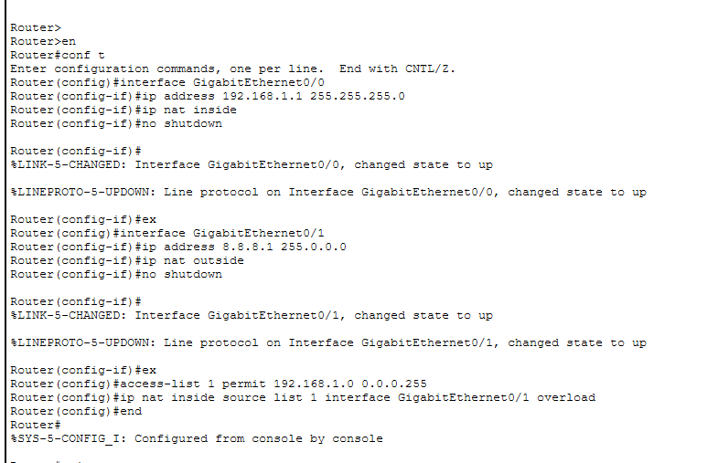
Router configuration for NAT

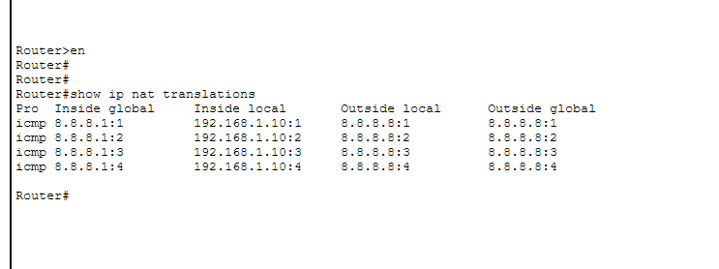
This is a command that shows the private Ips being changed to public Ips.

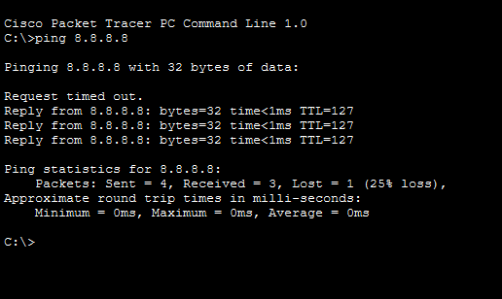
The ping command shows that there is connection between internal PC and the server that means the NAT worked.

This demonstrates how NAT preserves the limited supply of public IPv4 addresses while providing a layer of security by hiding internal private IP addresses from the public internet. The use of Overload ensures the network is scalable for additional internal devices without requiring further public IP allocations.

